Mac OS X Setup instructions

Software required: Raspbian Imager for Mac OS

Terminal

Angry IP Scanner

Terminal: The Terminal app is in the Utilities folder in Applications. To open it, either open your Applications folder, then open Utilities and double-click on Terminal, or press Command - spacebar to launch Spotlight and type "Terminal," then double-click the search result.

You’ll see a small window with a white background open on your desktop. In the title bar are your username, the word "bash" and the dimensions of the window in pixels. Bash stands for "Bourne again shell". There are a number of different shells that can run Unix commands, and on the Mac Bash is the one used by Terminal.

Flashing Raspbian

1. After the Raspbian Buster Zip is Installed(Link in Github ReadMe.md)
2. Open up the installed imager for Mac OS
3. Connect the SD Card to your MAC
4. Follow the Graphical Interface Instructions
5. Once you have flashed the Raspbian on the SD card

Open up the file system and direct yourself to the boot folder

1. Make a file named ssh without extensions(ignore all warning)
2. Make another file named wpa_supplicant.conf(with .conf extension)
3. Copy and Paste from the Github repo (Makers_RPI)and fill in your wifi details(This allows the raspberry Pi to connect to the same wifi network as your laptop or computer)
4. Open up the terminal and type ‘ipconfig getifaddr en0’( no inverted commas) to find ipv4 address
5. Copy and Paste ipv4 into Angry IP Scanner delete numbers after last decimal place and replace them with 1-254 and scan
6. U should obtain a device named raspberry pi on the scanner, copy its ipv4 address

SSH

1. Open terminal and type ssh user@IP-Address
2. In this case user is pi and IP address is the IP u have just copied
3. U should see this:

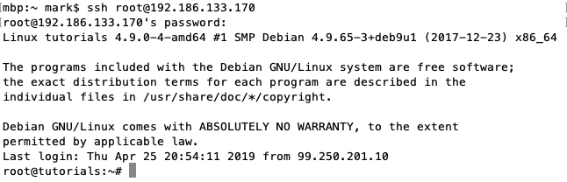

Default password is raspberry

Type sudo raspi-config and u should see

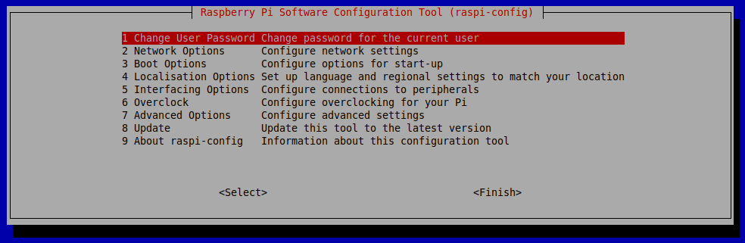

Go to interfacing options and enable ssh and VNC

With your copied IP open up VNC and paste the ip of the raspberry Pi into the space above

You will be prompted for password and username, this is same as before and if any warning pop up just click continue

If successful you should see this:

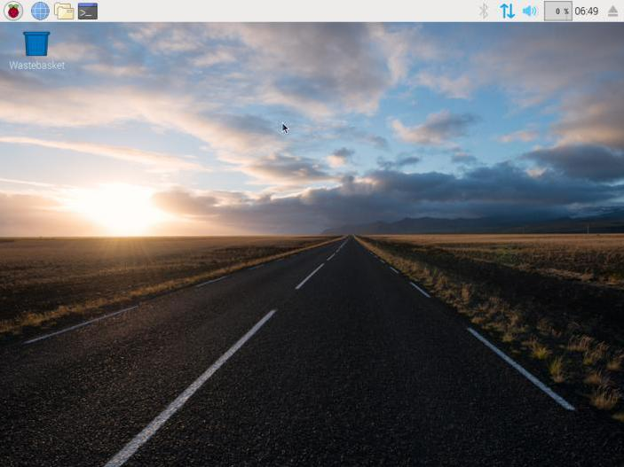

Congrats!:)

Troubleshooting

1. If the ssh cannot connect ensure you are connected to the same wifi as the raspberry Pi as state in the wpa_supplicant.conf file
2. If screen appears to be too big adjust setting with sudo raspi-config